**TIẾT 1- UNIT 2: REVISION**

**Tiết 1: REVIEW UNIT 1**

1. **Choose the word or phrase that best fits each of the blanks:** 
   * + 1. _____________ class are you in? - I'm in class 7B.

a. Where            b. How many        c. Who        d. What

1. Nam is a friendly person. He has______________ friends.

a. some             b. a lot of             c. few   d. much

1. What is her____________ name? - Pham Thi Hoa.

a. last                 b. family              c. full           d. middle

1. Hoa lives_____________Ha Noi, _____________12 Tran Hung Dao Street.

a. In - on                 b. in - at               c. at - on            d. on - at

1. ______________is it from here to school? - About two kilometers.

a. How far              b. How high            c. How long          d. How often

1. My father never drinks _______________ coffee for breakfast.

a. much                    b. many                     c. a lot of          d. a & c

1. ____________ is your new address (địa chỉ)?

a. Where                       b. What                   c. How                     d. When

1. She doesn’t have ____________ friends.

a. much                            b. many                          c. a lot of               d. b & c

1. Minh ____________ T. V every night.

a. watch                              b. watches                  c. watchs                         d. watching

1. She has _____________ of friends in the town.

a. some                               b. any                           c. lots                          d. lot

1. **Give the correct forms of the words in parentheses:**
2. They are _____________________ to their teacher. (talk)
3. Her new school______________________ than her old school. ( big)
4. Many things in Hanoi are ______________________ from in Hue. ( differ)
5. She has a lot of _________________________ in her new school. ( friendly)
6. **Read the passage then choose the best answer for each blank:**

My name is Nguyen Minh Trung. I am a (15) …………………..student in class 7A. I am from Da Nang and my family (16) …………………..live there. In Ho Chi Minh City, I live (17) …………………..my grandparents at 21/3B Nguyen Trai Street. My new school is not (18) …………………..from our house – about one kilometer, so I (19) …………………..to school by bike. There are a (20) …………………..of students in my new school. But I don’t have any friends. I am unhappy. I miss my parents, my sisters and my friends in Da Nang.

1. A. new B. old C. newest D. older
2. A. often B. still B. then D. that
3. A. on B. with C. from D. to
4. A. near B. next C. far D. further
5. A. goes B. gos C. to go D. go
6. A. lots B. some C. lot D. many
7. Arrange these words into their correct orders:
8. old students / doesn’t have / My class./ many /

🡪

1. smaller / her old one / Hoa’s new school is / than

🡪

1. goes to work / by bus / Mrs Hoang / /every day.

🡪

1. **Write the second sentence so that it has a similar meaning to the first sentence:**

**Dạng 1: so sánh hơn (so sánh về 2 người hay 2 vật)**

**S(chủ ngữ)+ be+ short adj-er+ than+ O**

**S(chủ ngữ) + be+ more+ long adj+ than +O**

1. Her new school is bigger than her old school.

→ Her old school

1. Lan’s father is older than her mother.

→ Lan’s mother

1. Lan is taller than me.

🡪 I am

**Dạnh hỏi về nơi sống/ địa chỉ**

**Where+ do/does+ S+ live?**

**What is S’s address?**

**Lưu ý nếu S là I, you, we, they, he, she, it sẽ đổi sang tính từ sở hữu: my, your, our, their, his, her, its**

1. Where do you live?

🡪 What

1. Where does she live?

🡪 What

1. What is Lan’s address?

🡪Where

1. Where does Nam live?

🡪 What

1. What is his address?

🡪 Where

**REIVIEW UNIT 2**

1. **Choose the word or phrase (A, B, C, or D) that best fits the blank space in each sentence.**
2. __________ is your telephone number?

A. When B. Which C. What D. Why

1. Nga lives ________ 52 Nguyen Dinh Chieu street.

A. at B. on C. in D. by

1. Her birthday party is _______ Friday, August 20th

A. at B. on C. in D. by

1. ________ you have a test tomorrow morning?

A. Will B. do C. are D. does

1. __________ is your brother?

A. How age B. What age C. How old D. B&C are correct

1. Nhat _______ 9 years old on his next birthday

A. is B. will C. will be D. isn’t

1. When's your ______?

A. birthday B. day of birth C. date of birth  D. birthdate

1. Ba: Will he be free on Sunday? Nam:______

A. No, he won't B. No, he doesn't C. No. he isn't  D. No, he will

1. What's your ______?

A. date of birth B. birthdate C. birthday  D. day of birth

1. An: Will you be free tomorrow evening? Hoa: ______

A. Yes, I will B. Yes, I do C. Yes, I am  D. Yes, I won't

1. **Use the correct word form given in each sentence**
2. May I ask you a __________________question? (person)
3. Please ____________ me when there are test results. (information)
4. Would you like to join us to Lan’s _______________party? (birth)
5. Why is Hoa _______________? (worry)
6. **Choose the word or phrase that best fits the blank in the following passage.**

My name is Nam . I live (15)__________ my parents in Ho Chi Minh city . I have (16) __________ friends at school . My telephone number (17) _________ 348684395. I often (18) ___________ on the telephone. Now I am calling to my classmate to (19) _________ them to my birthday party. My birthday is (20) _______October 22nd, I will have my birthday party at home. The party will start at six o’clock and finish at eight.

1. A. with B. in C. at D. on
2. A. many B. a lot of C. lots of D. B& C correct
3. A. are B. has C.is D. have
4. A. talk B. meet C. play D. listen
5. A. miss B. finish C. invite D. join
6. A. in B. on C. at D. from
7. **Read the passage and decide whether the statements are True or False:**

Her name is Celia. She lives with her parents in Cambridge. Her address is 10 Station Road. Her telephone number is 8 262 387. She will be thirteen on her next birthday. It’s on Sunday, April 24th. She will have a small party for her next birthday. She will invite some of friends to her house. They will eat cakes and ice – cream. And they will have a lot of fun. Tonight, she will plan her party. At the moment, she is writing some invitations.

1. Celia’s birthday is on March 14th
2. She lives with her father and her mother.
3. Her address is 10 Station Road.
4. She is writing a letter.

**VI. Rearrange the words or phrases in the correct order.**

1. next Thursday morning / Lan / an English test / will have /.

🡪

1. in front of / tomorrow /the cinema / We will meet /.

🡪 \

1. next birthday / How old / on her / will she be / ? /

🡪

**VII. Rewrite the following sentences without changing their meaning.**

**Dạng hỏi tuổi:**

**How old is/ are+ S?**

**What is S’s age?**

**Lưu ý: các S: I, you, we they, he, she, it ⬄ tính từ sở hữu: my, your, our, their, his, her, its**

1 .How old are you?

🡪 What ?

2. How old is he?

🡪 What ?

3. How old is your friend?

🡪What is ?

**Dạng hỏi về ngày sinh**

**When is S’s birthday?**

**What is S’s date of birth?**

5. When’s your birthday?

🡪What is ?

6. When’s his birthday?

🡪What is ?

7. When’s her friend’s birthday?

🡪What’s ?

**THE END**

**Tiết 2: Unit 3 AT HOME**

**B1**

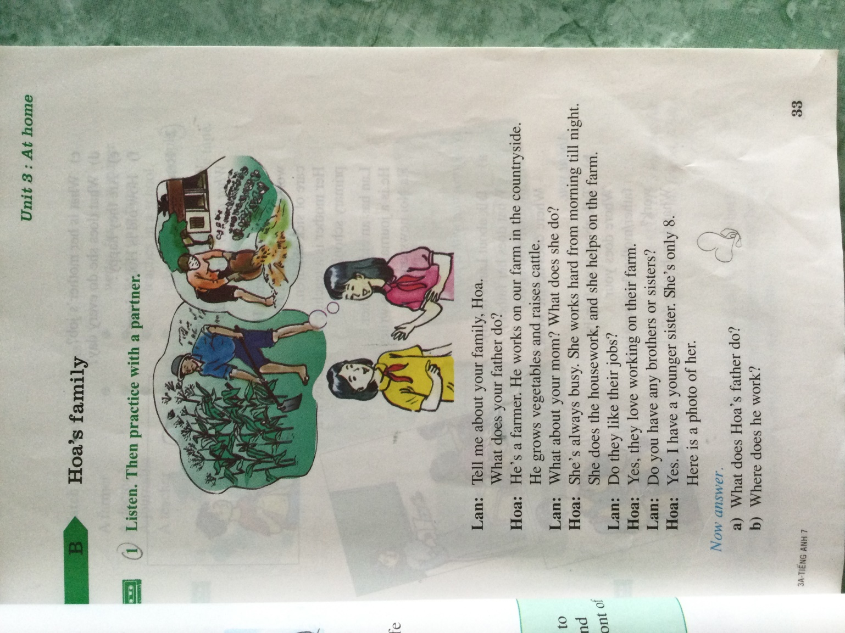

**Vocabulary:**

|  |  |  |
| --- | --- | --- |
| Word | Picture | Meaning (nghĩa) |
| 1. farmer (n.):  🡪 farm ((n.) |  | Nông dân  Nông trại |
| 2. countryside (n.) |  | Miền quê |
| 3. grow (v.) |  | Trồng |
| 4. vegetables: |  | Rau củ |
| 5. raise (v.) |  | nuôi |
| 6. cattle (n.) |  | Gia súc |
| 7. hard (adv.) |  | Chăm chỉ |
| 8. housework (n.) |  | Công việc nhà |
| 9. job (n.) |  | Nghề nghiệp |

**B2**

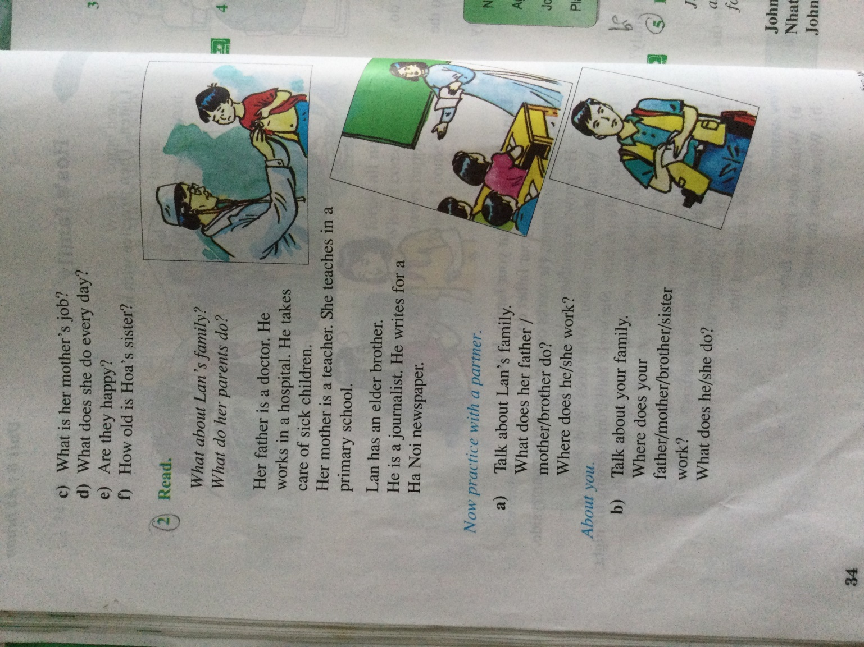

**Vocabulary:**

|  |  |  |
| --- | --- | --- |
| Word | Picture | Meaning (nghĩa) |
| 1. doctor (n.) |  | Bác sĩ |
| 2. hospital (n.) |  | Bệnh viện |
| 3. take care of= look after |  | Chăm sóc |
| 4. sick (a.) = ill (a.) |  | Bệnh |
| 5. children (n.) |  | Trẻ em |
| 6. teacher (n.) |  | Giáo viên |
| 7. primary school (n.) |  | Trường tiểu học |
| 8. journalist (n.) |  | Phóng viên |
| 9. newspaper (n.) |  | Báo chí |

**Exercise**

**Match**

|  |  |
| --- | --- |
| A farmer | writes for a newspaper |
| A doctor | works on a farm |
| A journalist | teaches in a school |
| A teacher | takes care of sick people |